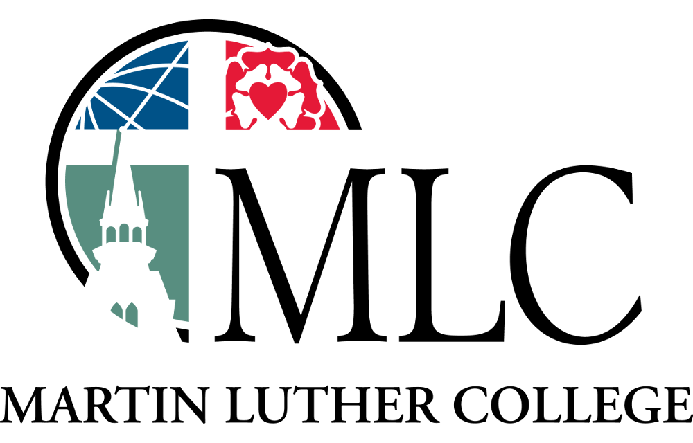

Martin Luther College
Pursuing Excellence Under the Cross

Suggested Readings & Hymns

First Lesson:
Isaiah 6:1-8 (sermon text)

Psalm:
96

Second Lesson:
Romans 10:11-17

Gospel:
Luke 24:44-48

Hymns:
498, 573, 314/317, 733

