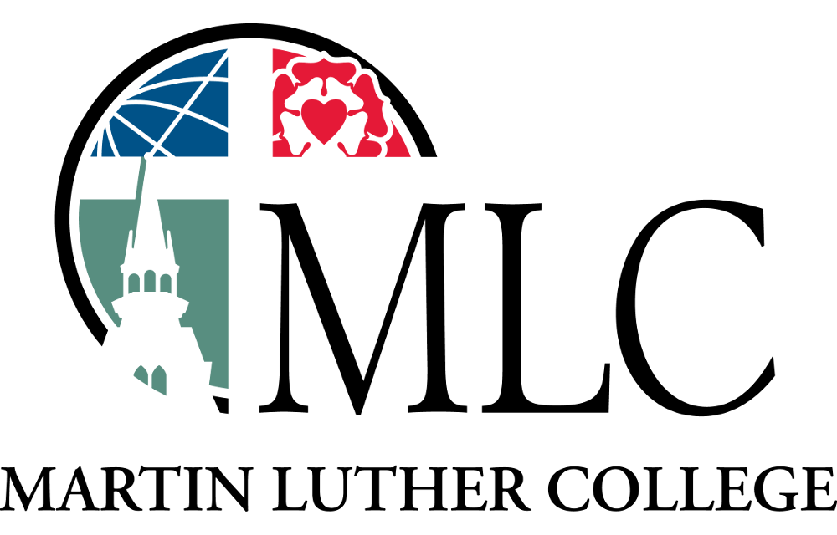
Pursuing Excellence Under the Cross

SINGLE POST-WORSHIP SUNDAY

Winter, Spring and/or Fall

Promoting MLC Sunday
The MLC strategic plan toolbox features an MLC Sunday repository for all the materials you can use to promote, conduct, and maintain your efforts to promote MLC.

- Text announcements - You can download announcements for your bulletin and/or newsletter to help you introduce the MLC Sunday and prepare your congregation for the special worship service.
- Graphics - You can download MLC graphics to enhance your announcements.
- Display slides - If your facility utilizes flat-screen displays, you can download customizable slides to promote the MLC Sunday.
- Social media - You can download MLC images to promote your upcoming MLC Sunday on your social media platforms. Consider sharing our “Tip of the Week” posts and videos, and encourage your followers to share as well!
- Casebooks – You can order these booklets, which clearly explain the needs and goals of Martin Luther College and include a remittance envelope for easy gifting. Order them from the toolbox and receive them in 4-5 business days.
- PowerPoint presentation – You can download this presentation and show it during Bible class or another appointed time.
- Videos: You can download video files, which include general descriptions and promotions of MLC. Our video page will continually be updated with stories from MLC students, faculty members, and other MLC supporters explaining the importance of MLC.

Before worship

- Share the announcement that introduces the MLC Pursuing Excellence Under the Cross strategic plan by letter, newsletter, email, or social media.
- Identify an MLC alumnus to offer a testimonial after worship. Encourage them to prepare a 2-4 minute testimony. (Suggested speaking points: How God strengthened my faith at MLC, how MLC provided skills and a gospel focus for my life and ministry, how MLC was a blessing to me, how MLC is a blessing to all of us.)
- If your church uses flat-screen displays, download the customizable slides from the MLC toolbox to introduce the upcoming MLC events.
- Share MLC information with the congregation via email and/or social media. (Download slides, videos, and “Tip of the Week.”)
- Download and print the MLC bulletin insert for inclusion in Sunday bulletin. Note that it does not include a ready-to-use giving option.

Worship service
- Use or adapt our prepared sermon (written by Mark Zarling).
- Download and include one of the prepared prayers in your service.
- Hand out MLC Pursuing Excellence Under the Cross casebooks by 1) inserting into service bulletins, 2) placing in mailboxes, 3) handing out as people enter the sanctuary for worship, 4) handing out as people leave the sanctuary after worship.

After worship
- Pastor can offer a testimonial about MLC. (Suggested speaking points: How MLC provides excellent ministerial training, including liberal arts education, professional education, and service/ministry opportunities. How called workers at your congregation were educated at MLC and its predecessor, NWC. Name all those called workers, calling attention to the direct line from MLC (and WLS) to congregations. Ask other D/MLC/NWC graduates to raise their hands—they too are using their training in many different ways.)
- MLC alumnus #3 can offer their testimonial. (See Week 1, Point 2)
- Show an MLC promotional video:
  - https://vimeo.com/364312119
  - https://player.vimeo.com/video/353827606
- Pastor can present the “Ask” (1 minute). Suggested wording: You’ve learned some valuable information about MLC. I encourage all of our members to prayerfully consider a special gift to MLC, investing in this ministry that is a wonderful blessing for our synod and our own congregation. Envelopes are in the casebooks, or you may give electronically.
- Pastor can dismiss the congregation.

Bible class: Present the MLC PowerPoint one or more Sundays.
(Download from the MLC toolbox.)

Subsequent Sundays
- During worship services in the subsequent two weeks, the pastor may share the following reminder: “For those of you who have responded to the MLC Pursuing Excellence Under the Cross strategic plan, thank you for responding generously! It is greatly appreciated and a way to invest in our WELS College of Ministry and also our own church. If you have not given a gift, please consider doing so. If more casebooks are needed or you did not receive one, they’re located ________. The ushers are also handing them out today.”
- Bible class: Continue to present the MLC PowerPoint one or more Sundays. (Download from the MLC toolbox.)
- Social media: Continue to share MLC information with the congregation via email and/or social media. (Download slides, videos, and “Tip of the Week.”)

