YOU CAN BE AN ECW PRESENTER!
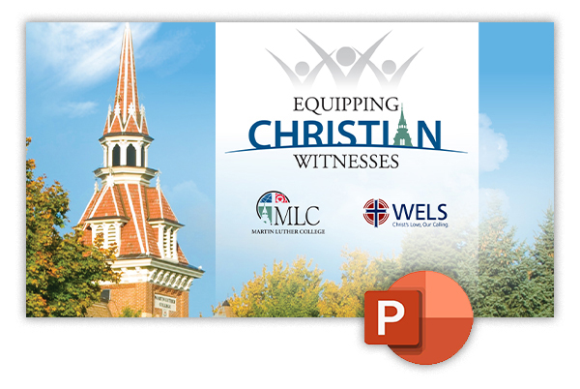
We’ve received requests from MLC supporters who want to present information about Equipping Christian Witnesses to their congregation or congregational group.
We’ve made it easy with this ECW PowerPoint presentation, complete with speaking notes for the presenter! Just order casebooks to hand out, download the presentation, and you’re ready to go! You can find all this and more, at our online toolbox. https://mlc-wels.edu/ecw-toolbox/

