SOCIAL MEDIA GRAPHICS
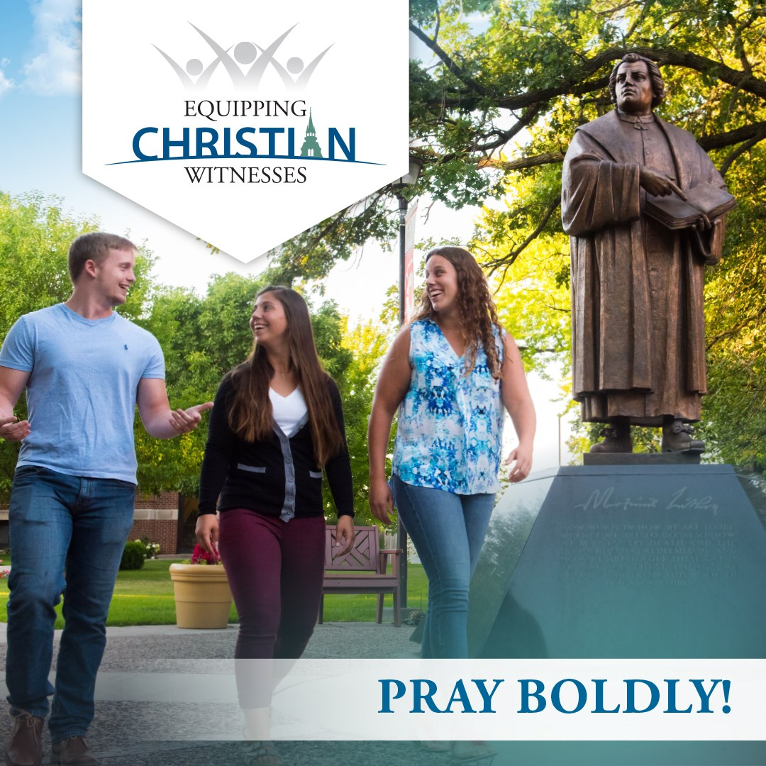
If your congregation subscribes to the WELS Connection, you'll see more information about ECW on a weekend soon! This would be a great time to share our campaign on social media with graphics (like we have in this post) with your own statements of support.
You'll find more graphics like this, along with printed materials and videos in our ECW toolbox at
https://mlc-wels.edu/ecw-toolbox

