SHARING IDEAS
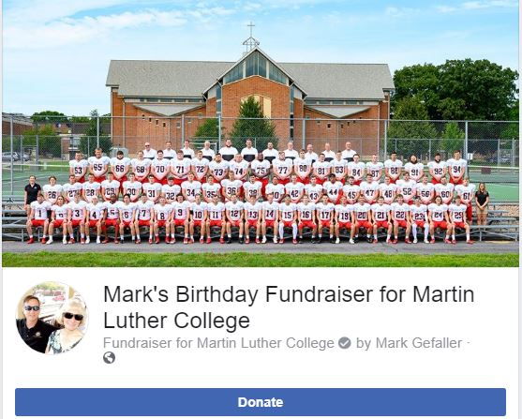
We are so humbled by all the creative methods our supporters are using to support our ministry at MLC. We've seen several social media ideas like the one Mark used on his birthday. He writes, "I saw on Facebook that you can do fundraisers. I saw MLC was on the list and wanting to support one of our synodical schools I chose it. I'm happy to see the support!" Thank you, Pastor Gefaller!

