RECOMMEND A STUDENT!

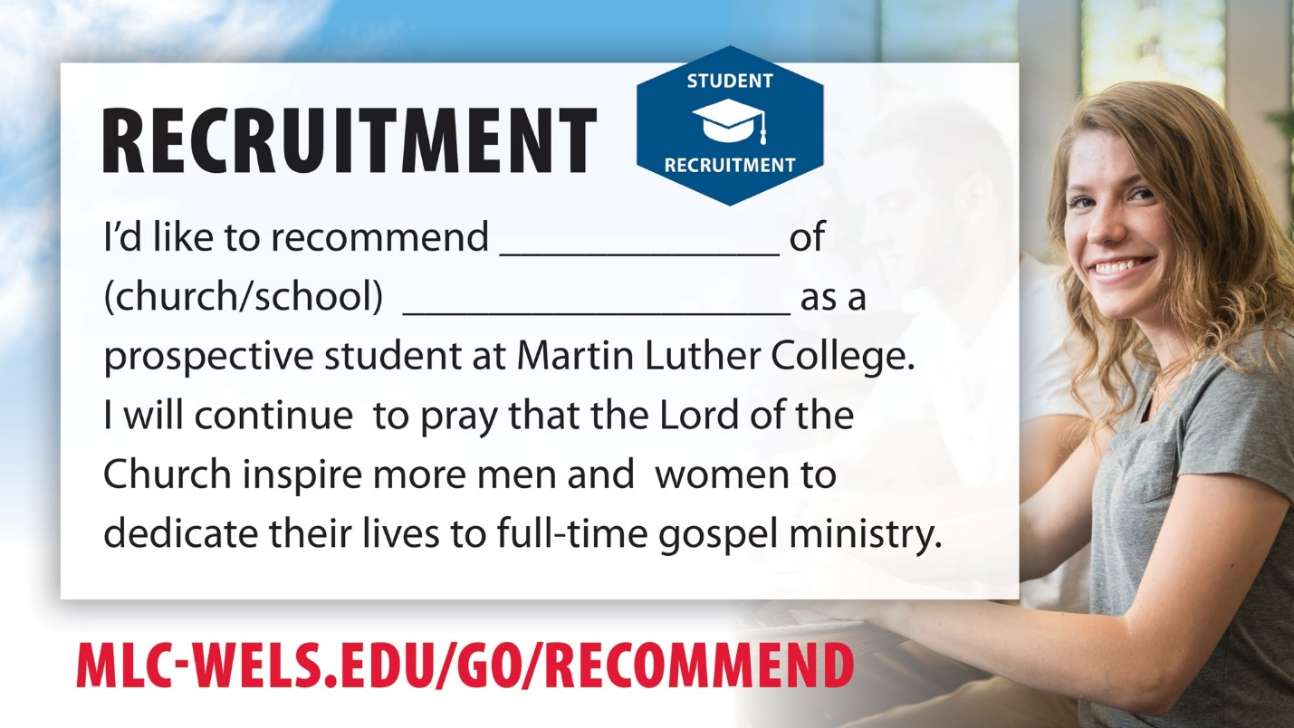

The first, and most important, pillar of MLC's Equipping Christian Witnesses campaign is recruitment.

We pray that everyone in our churches and schools will consider recommending children in their congregations who are 13 years and older (re. child privacy laws) to receive information from MLC regarding a future in the public ministry.

Use the url listed, or follow this link to recommend a student!

[https://mlc-wels.edu/ecw-student-referal-form](https://mlc-wels.edu/ecw-student-referal-form?fbclid=IwAR2ZASwwZUFll0YgFuFwh8SKTagQuISOlcxTLpMRqbVkfSXE-v_tU1FcEdE)