BULLETIN INSERTS
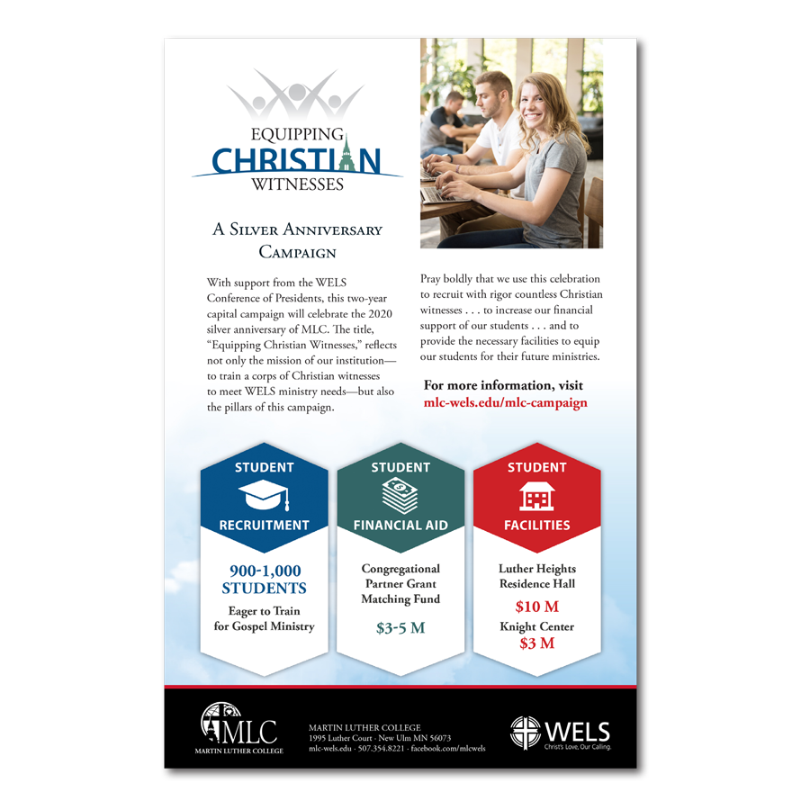
Want an easy way to introduce Equipping Christian Witnesses to your congregation? Order full color, ready to use bullet inserts (8.5″ x 5.5″).
These inserts will provide a summary of the ECW campaign and its importance for WELS. Please order the quantity you need and we will ship them to you. Order your inserts today at
https://mlc-wels.edu/product/ecw-bulletin-inserts/

