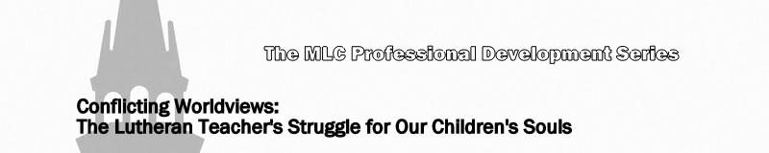
Lesson 7: Cautions and Encouragements

- See I Corinthians 5:6.

- What warning is sounded by the Apostle Paul?

- See Colossians 2:8 and 2 Corinthians 10:5.

- What two important points are made by these passages with regard to false worldviews?

a.

b.

- See Ecclesiastes 1:9 and Matthew 24:10-14.

- What two reminders are provided by these scripture references?

a.

b.

