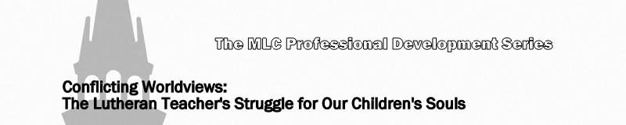
Lesson 6: Spiritualism (Paganism)

- What is paganism?

- The occult –

- Polytheism –

- Scriptural admonition/parental advice

- Exodus 20:2,3
- Leviticus 19:26,31; 20:6
- I Samuel 15:23
- 2 Kings 21:6
- Acts 16:16-18; 19:18,19
- Galatians 5:19-21
- I Timothy 4:1
- Revelation 9:21; 21:8; 22:15
What advice would you give to a parent on this topic?

