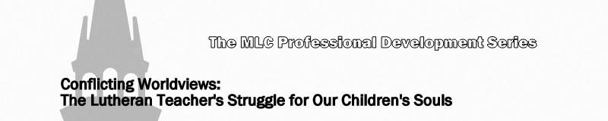
Lesson 3: Modernism (Naturalism, Secular Humanism and Theistic Existentialism)

See Genesis 3:1-5; Genesis 6:1, 2 and 5; and Genesis 11:1-4.

- What is modernism?

Read 2 Timothy 4:3

The Modernism family tree—related worldviews

- Naturalism

- Naturalism and Bible interpretation

- Literary or historical criticism (higher critical method) –

- Textual criticism (lower critical method) –

- Historical-grammatical –

- Darwinism

- Secular humanism

- Theistic existentialism

- See Matthew 12:40,41; Matthew 19:4-6; 1 Timothy 2:13,14; Hebrew 11:7; 1 Peter 3:20; 2 Peter 2:5
- See I Corinthians 15:3,4,13,14,17,18

