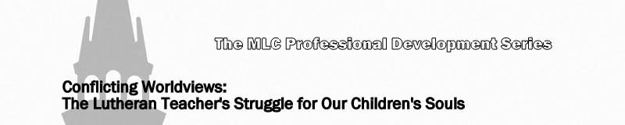
Lesson 1: What Worldviews Are and Why Christians Should Understand Them

Introduction

- What is a worldview?

Discuss:

- What are some factors that can influence worldview (see 2 Timothy 4:3,4)?

- What is the source of a truly objective and truthful worldview (see John 17:17b)?

- Identify the source of all false worldviews (see John 8:44)?

- Prevalent worldviews today

- Searching the Scriptures

Does worldview really matter? Doesn’t the Bible tell us not to judge what others believe?

- Matthew 7:1

- John 7:24

- 1 John 4:1
- Acts 17 (esp. vv. 10-12)

- Galatians 5:9

- Hebrews 13:8

- How are worldviews dangerous?

Contrast Revelation 2:13-16 with Revelation 3:8-10.

- A Lutheran confessional worldview

Christian vs. biblical vs. Lutheran … How do we describe ourselves? Is there a difference?

The Book of Concord

- Why Christians should study worldviews

h.

